**Modifying application provided Portlet - customization -** [**Modifying application-provided portlets - IBM Documentation**](https://www.ibm.com/docs/en/store-engagement?topic=portlets-modifying-application-provided)

Putaway-portlet customization

In the app-config-overrides.json file make sure useRemote value is false for override-component

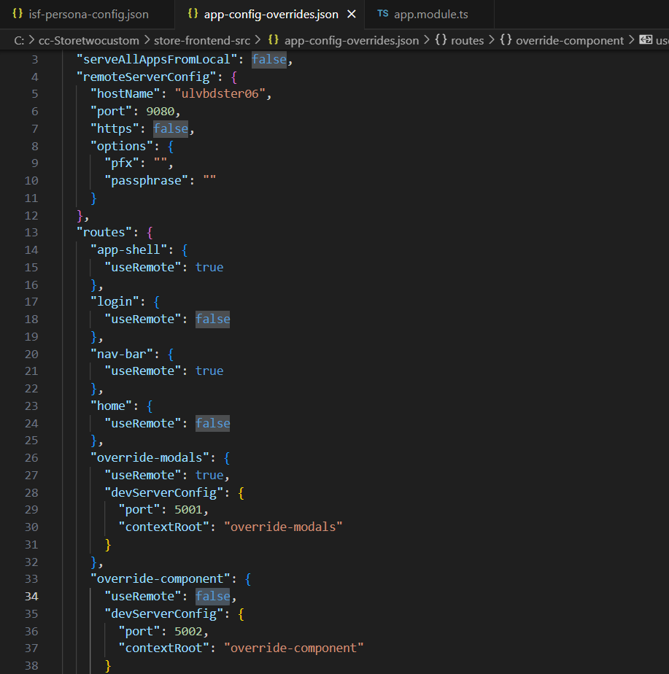

1. Copy the appropriate application-provided portlet component folder from <store-temp>/packages/features/home/src/app/portlet-set directory to the <store-temp>/extensions/features/override-component/src/app/components directory.

Copy portlet-set folder from C:\cc-CustomStore**\store-frontend-src\packages\features\home\src\app\portlet-set\putaway-portlet** paste to

C:\cc-CustomStore\**store-frontend-src\extensions\features\override-component\src\app\components\putaway-portlet**

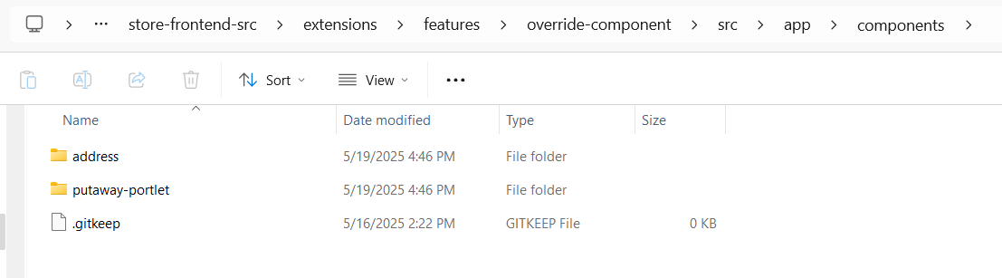

1. In the component.ts file of the portlet, update the portlet's component class name with custom eg - PutawayPortletComponentCustm. Add the componentName variable and update the portletname and componentName variables with the component class name.

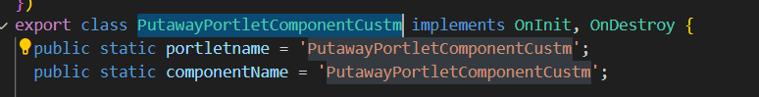

1. Update the portlet component class name by completing the following steps:
   1. Browse to the /extensions/features/override-component/src/app/ directory.
   2. Open the apps.module.ts file.
   3. In the customComponentsDeclarations object, update the portlet component class name.
   4. Import the portlet component class name.

C:\cc-CustomStore\**store-frontend-src\extensions\features\override-component\src\app\app.module.ts**

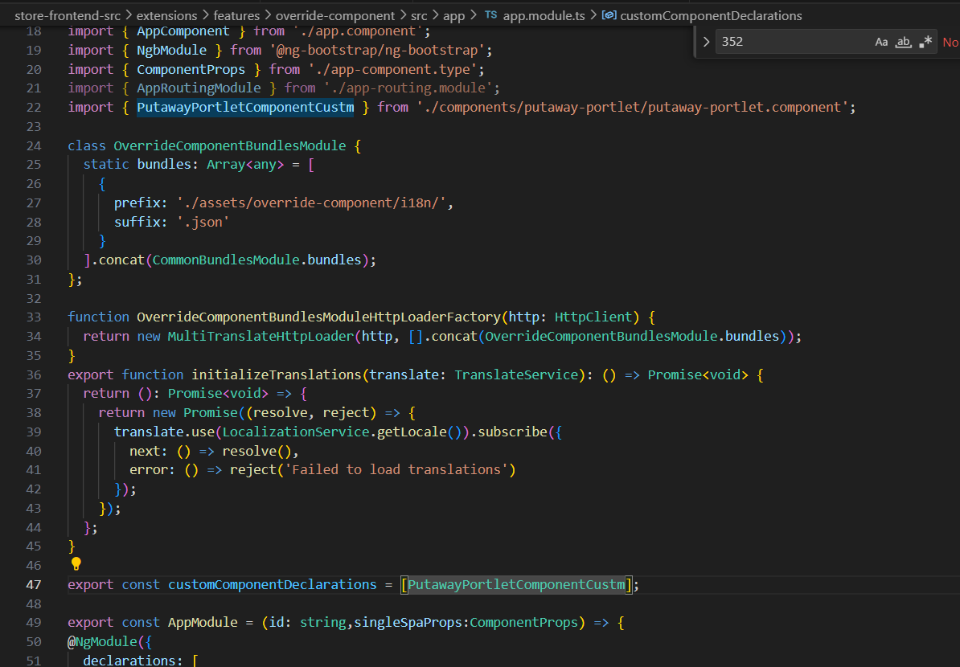

1. Copy the application-provided portlet JSON configuration from the <store-temp>/packages/features/app-shell/src/assets/app-shell/config/isf-persona-config.json file to the <store-temp>/extensions/override-static-assets/portlets/config/isf-persona-config.json file. You can identify the application-provided portlet by using the component class name. Also, add the extensionType attribute with appropriate value.

Copy C:\cc-CustomStore\store-frontend-src\**packages\features\app-shell\src\assets\app-shell\config\isf-persona-config.json** to C:\cc-CustomStore\store-frontend-src\**extensions\override-static-assets\portlets\config\isf-persona-config.json**

1. n the JSON configuration, update the custom portlet component class name in the portletComponent attribute that you copied to the <store-temp>/extensions/override-static-assets/portlets/config/isf-persona-config.json file.

**Note:** In the JSON configuration, do not change the portletTID attribute.

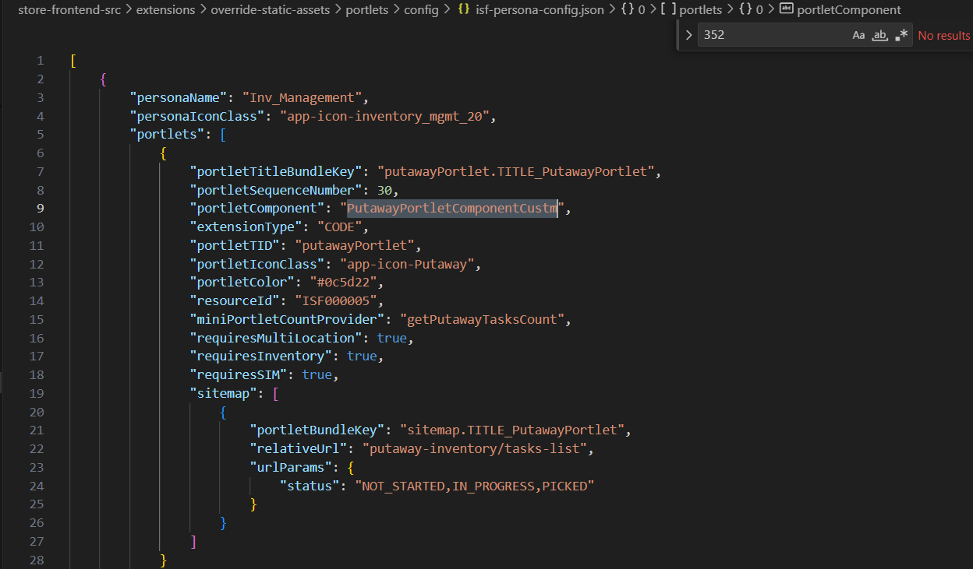

1. 6. **Including Bundle assets:**    
   ***from-path****: C:\IBM\oms10\repository\store\store-frontend-src\packages\features\home\src\assets\home\i18n\en.json*   
   ***to-path****: C:\IBM\oms10\repository\store\store-frontend-src\extensions\features\override-component\src\assets\override-component*   
   *In to-path create home and i18n folder and copy paste the en.json from from-path*   
   ***Path****: C:\IBM\oms10\repository\store\store-frontend-src\extensions\features\override-component\src\app\app.module.ts*

***File****: app.module.ts*

|  |
| --- |
| class OverrideComponentBundlesModule {    static bundles: Array<any> = [      {        prefix: './assets/override-component/i18n/',        suffix: '.json'      },      {        prefix: './assets/home/i18n/',        suffix: '.json'      }    ].concat(CommonBundlesModule.bundles);  }; |

**Modifying application provided Wizard screen** - [Modifying application-provided wizard screens - IBM Documentation](https://www.ibm.com/docs/en/store-engagement?topic=interface-modifying-application-provided-wizard-screens)

Here deposit-products-page, is modified which is inside lookup-inventory

1. Below is the sample generic code

yarn override-route --module-name=<module-name> --override-module-name=<override-module-name> --override-component-folder-name=<component-name> --port=<port>

Run this command inside C:\cc-CustomStore\store-frontend-src

**yarn override-route --override-module-name=lookup-inventory --module-name=extn-lookup-inventory --override-component-folder-name=product-list-page --port=7793**

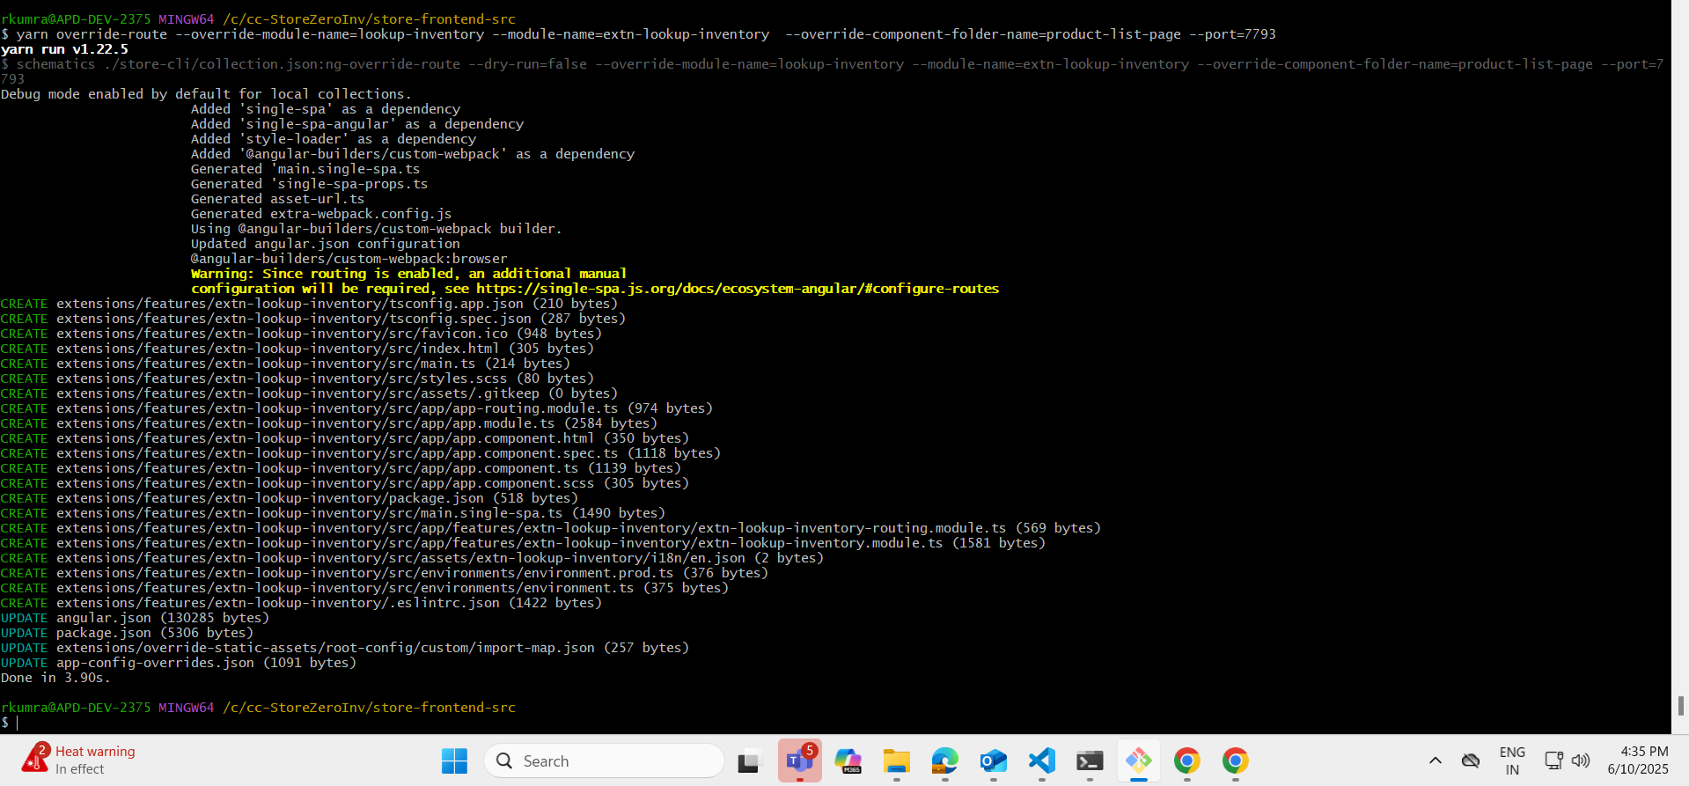

**(Info -** this port is any 4 digit random number, when you run this command it will generate devServerconfig in backend in app-config-overrides.json file with the port number for module-name which you have created)

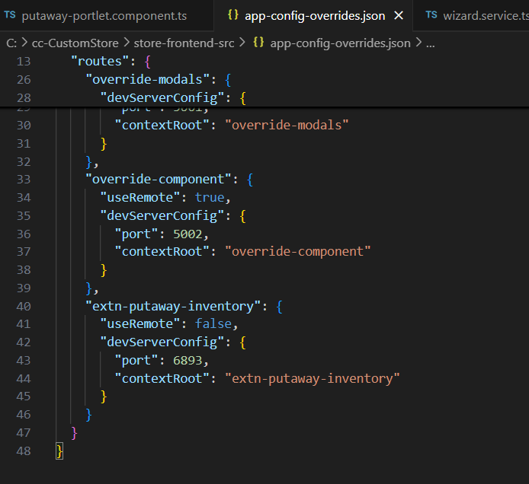

1. C:\cc-StoreZeroInv\store-frontend-src\extensions\features\extn-lookup-inventory\src\app\features\extn-lookup-inventory/extn-lookup-inventory-module.ts

Add providers from C:\cc-StoreZeroInv\store-frontend-src\packages\features\lookup-inventory\src\app\features\lookup-inventory\lookup-inventory-routing.module.ts

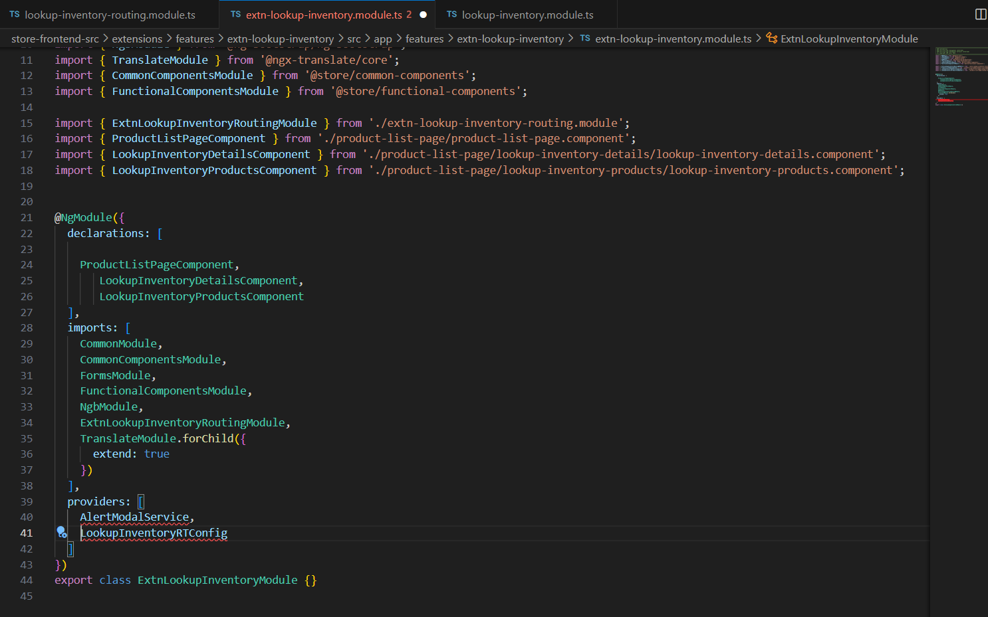

Import them

1. Update Custom routes.json to consider our custom folder - C:\cc-StoreZeroInv\store-frontend-src\extensions\override-static-assets\root-config\custom\routes.json, route path is cpied from - C:\cc-StoreZeroInv\store-frontend-src\packages\apps\store-root-app\src\assets\root-config\config\feature-routes.json

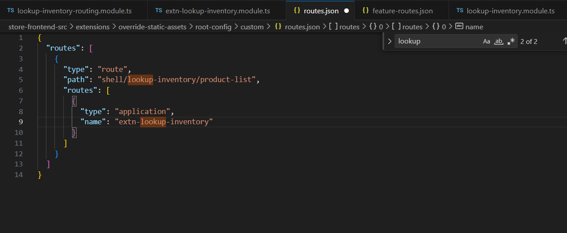

1. Update Routes in custom-routing.module.ts file  
   C:\cc-StoreZeroInv\store-frontend-src\extensions\features\extn-lookup-inventory\src\app\features\extn-lookup-inventory\extn-lookup-inventory-routing.module.ts add Routes, take route from C:\cc-StoreZeroInv\store-frontend-src\packages\features\lookup-inventory\src\app\features\lookup-inventory\lookup-inventory-routing.module.ts

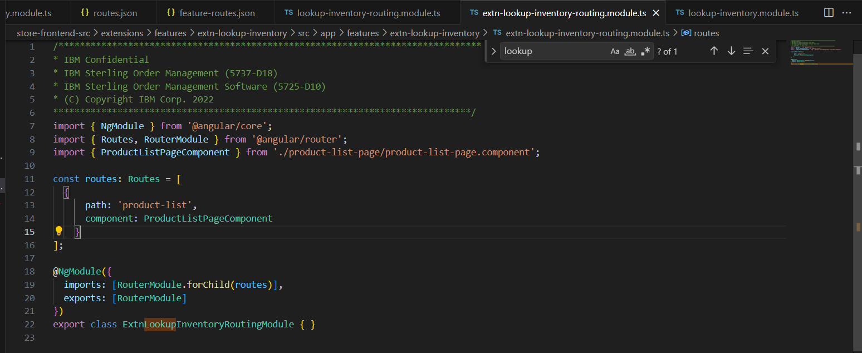

1. Yarn start-app

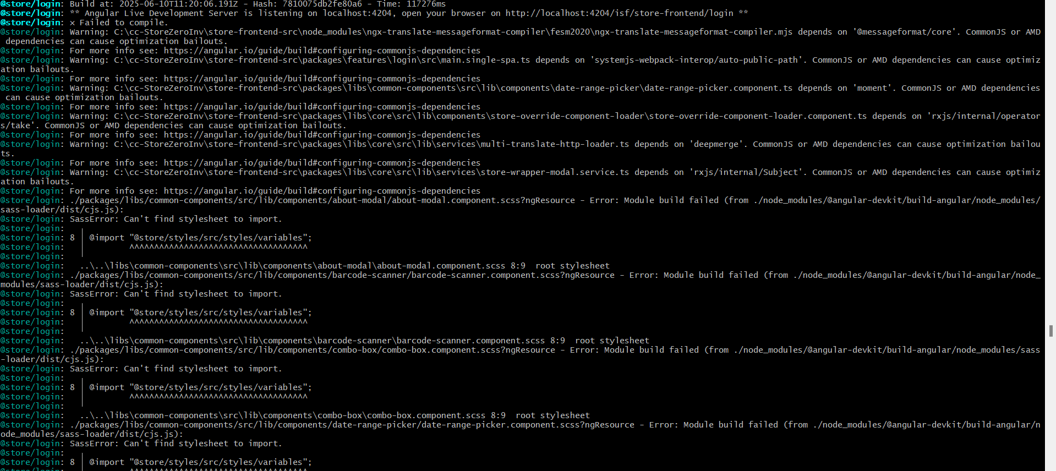

For resolving above error-   
yarn override-route --override-module-name=lookup-inventory --module-name=extn-lookup-inventory --override-component-folder-name=modals --port=7793



If still error is there then delete node modules folder and then run yarn bootstrap and yarn start-app

Above error is resolved , now new error below

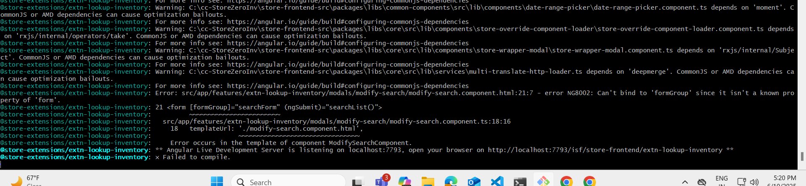

In extn-lookup-inventory-module.ts add ReactiveFormModule in imports

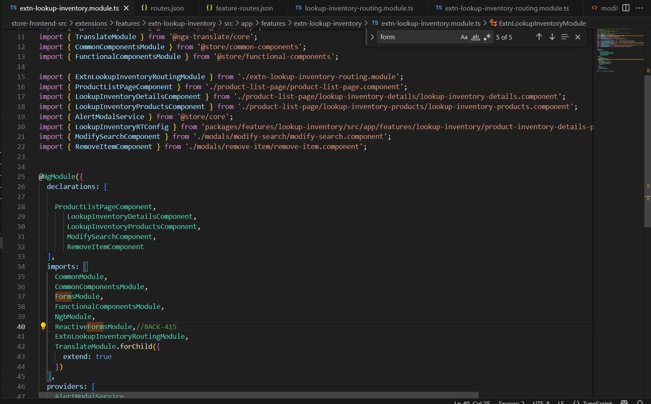

Yarn start-app

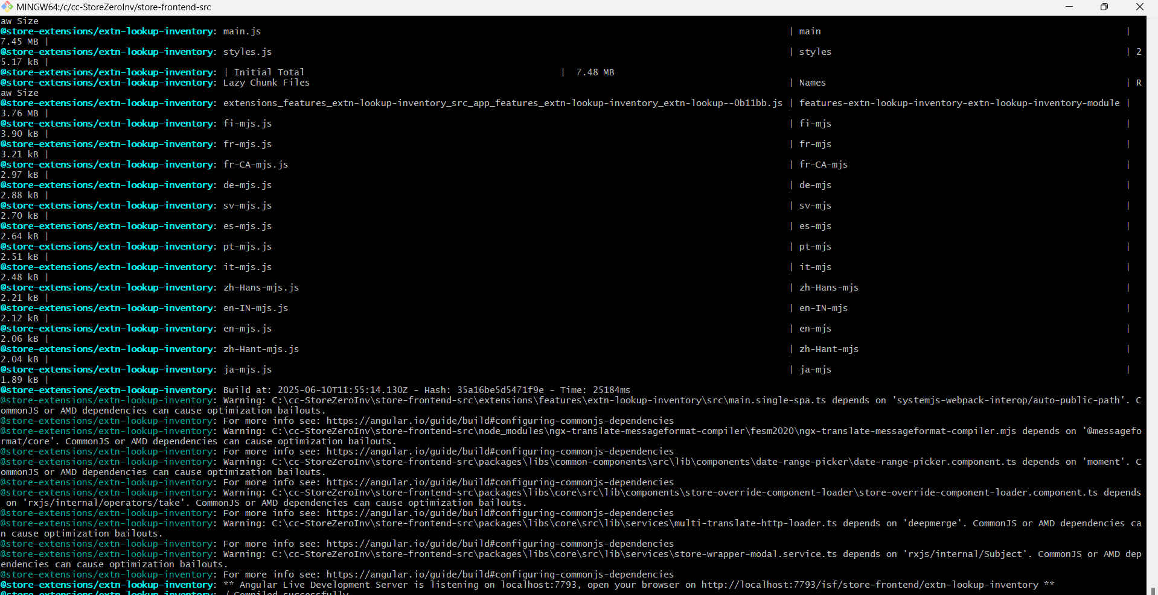

Now customize your code